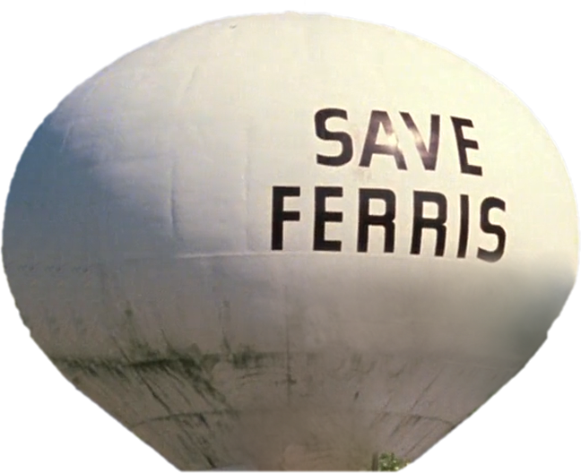



The Race HoMe

The question isn't "what are we going to do," the question is "what aren't we going to do?" **~ Ferris Bueller**

Feburary 14, 2016

RaVeN Madd Studios

Ver. 1.0



The Race Home is a pixelated endless runner homage to the Ferris Bueller’s Day Off Movie and the Race Home scene.

Choose from a verity of characters as you must traverse through, on and around various objects in hopes to get home first.

# Game

Genre

Endless Runner, Parkour, Touch

Art Style

Pixelated, 8-bit, retro

Audio Style

ChipTune, 8-bit

View Angle

Platform

Mobile (Primary), PC, Console (if feesible)

Multiplayer

None. (potential 2-player race)

Features

Scoreboard. (online?)

# Characters

# Play Modes

Levels

Challengers

Endless

# Mechanics

Parkour

Swiping in various directions at the peak of a jump allows for parkour moves which speeds up the player slightly.

Increase Speed

After consecutive parkour moves a speed bonus is granted.

# Controls

Mobile

Swipe

Tap

PC

Keyboard

XBOX

Console

PS4

XBOX

Workload

# Programming

# Art Assets

* Land Plots
* Houses
* Jump Objects (active parkour)
  + Fences
  + Dog House(s)
  + BBQ
* Jump Objects (no active parkour)
  + Bush(s)
  + Flower Bed
  + Plastic Kid Pool
* Characters
* Vehicles
* Non Interact Objects

# Audio Assets

# Animation

The Race Home is an endless runner style game which takes place through a suburban neighborhood.

* Pixel art style
* Parkour character animations
* Race against parents in car, mimicking The Race Home scene from Ferris Bueller’s Day Off.
* Player must stay within reasonable distance of parents.
  + Or ahead of them.
* Players gain a point of speed with each consecutive set of overcome obstacles.
  + 2 for lvl 1, 5 for lvl 2, 10 for lvl 3, 20 for lvl 4, 50 for lvl 5
    - Possible hidden lvl 5 and 6.
* Difficulty in Endless Mode increases by:
  + Player gaining speed (up to five points)
  + More obstacles to overcome in the yards
    - Dogs that run around after the player
  + Sun goes down, Low lighting by street lights.
  + Power goes out and everything is lit with one angle of Moon light.
  + Clouds cover the Moon and is almost completely pitch black.

HUD

* Additional Speed points
* Distance traveled
* Time (Remaining/Elapsed (Endless)
* Position Bar (Player vs Parents)

Model Assets

1. 5+ Houses
2. Fences
   1. Hedge (Flowers (Various Colors)
   2. Wood Fence (Various Colors)
3. Bush
4. Small Tree (orange, apple)
5. Dog House

Model Assets

1. 5+ Houses
2. Fences
   1. Stone (Various Colors)
   2. Hedge (Flowers (Various Colors)
   3. Wood Fence (Various Colors)
   4. Chain link
3. Bush
4. Small Tree (orange, apple)
5. Dog House
6. BBQ (Old round model, new square style)
7. Flower Bed
8. Kids Plastic Swimming Pool
9. In Ground Pool (Various Floating Objects to Jump On)
10. Bird House
11. Kids Swing Set
12. See Saw
13. 5+ Vehicles
14. Playground
15. School

Character outfits

* Ferris Robe

LandMarks

* Save Ferris Water tower
* 1961 Ferrari 250 gt California(driven by the to parking guys)
* Parade with german flaot playing
* School bus
* Cab 1793